Bestop Is Your Best Stop at SEMA 2022

Louisville, Colorado -

Bestop, the leading supplier of Jeep tops and accessories, and the Bestop Premium Accessories Group are returning to SEMA in 2022! The Bestop booth (#55101) will be a must-stop with a lineup of incredible events and display vehicles that will wow enthusiasts and adventurers of all stripes. Featuring Jeeps and Broncos, both classic and modern, and our friends from MotorTrend’s Dirt Every Day, you won’t want to miss it.

A Colorado company, Bestop has been outfitting Jeeps with top tier accessories since 1954, an unrivaled legacy in the industry. We still proudly design and manufacture our lineup of tops for a wide range of makes and models right here in North America.

To celebrate 68 years of this heritage, “Pigpen”, Ned Bacon’s legendary 1949 Willys Jeep CJ-3A will muddy the floors of the Bestop booth all week. Of course, it will be sporting Bestop’s Tigertop, one of our oldest soft top designs - still in production today. Looking toward the future, the new hybrid Jeep Wrangler 4xe will also be on display, sporting the new JL Supertop soft top and a variety of Bestop Premium Accessories Group products.
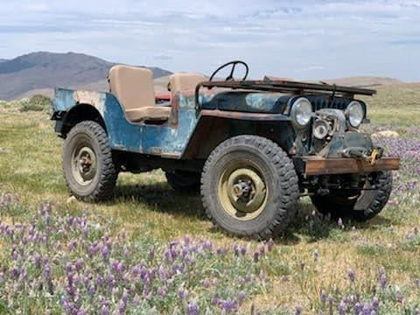
“Pigpen”

For the Ford folks, we will be showing off our newest additions to the Bestop range, the Trektop soft top and Skyrider sunroof panel for the new Ford Bronco. Ford’s revival of this renowned off-roader has been one of the most exciting developments in the 4x4 world recently.

To keep the Bronco buzz going Dave Chapelle and Fred Williams as seen on MotorTrend’s Dirt Every Day will be displaying their ultra-rare 1966 U13 Roadster Ford Bronco in the Bestop booth. Dave and Fred will be available to chat to fans through the week. We’re thrilled to have them along for the ride with Bestop at SEMA 2022. Stop by our Bestop booth for a meet and greet and a signed autograph.
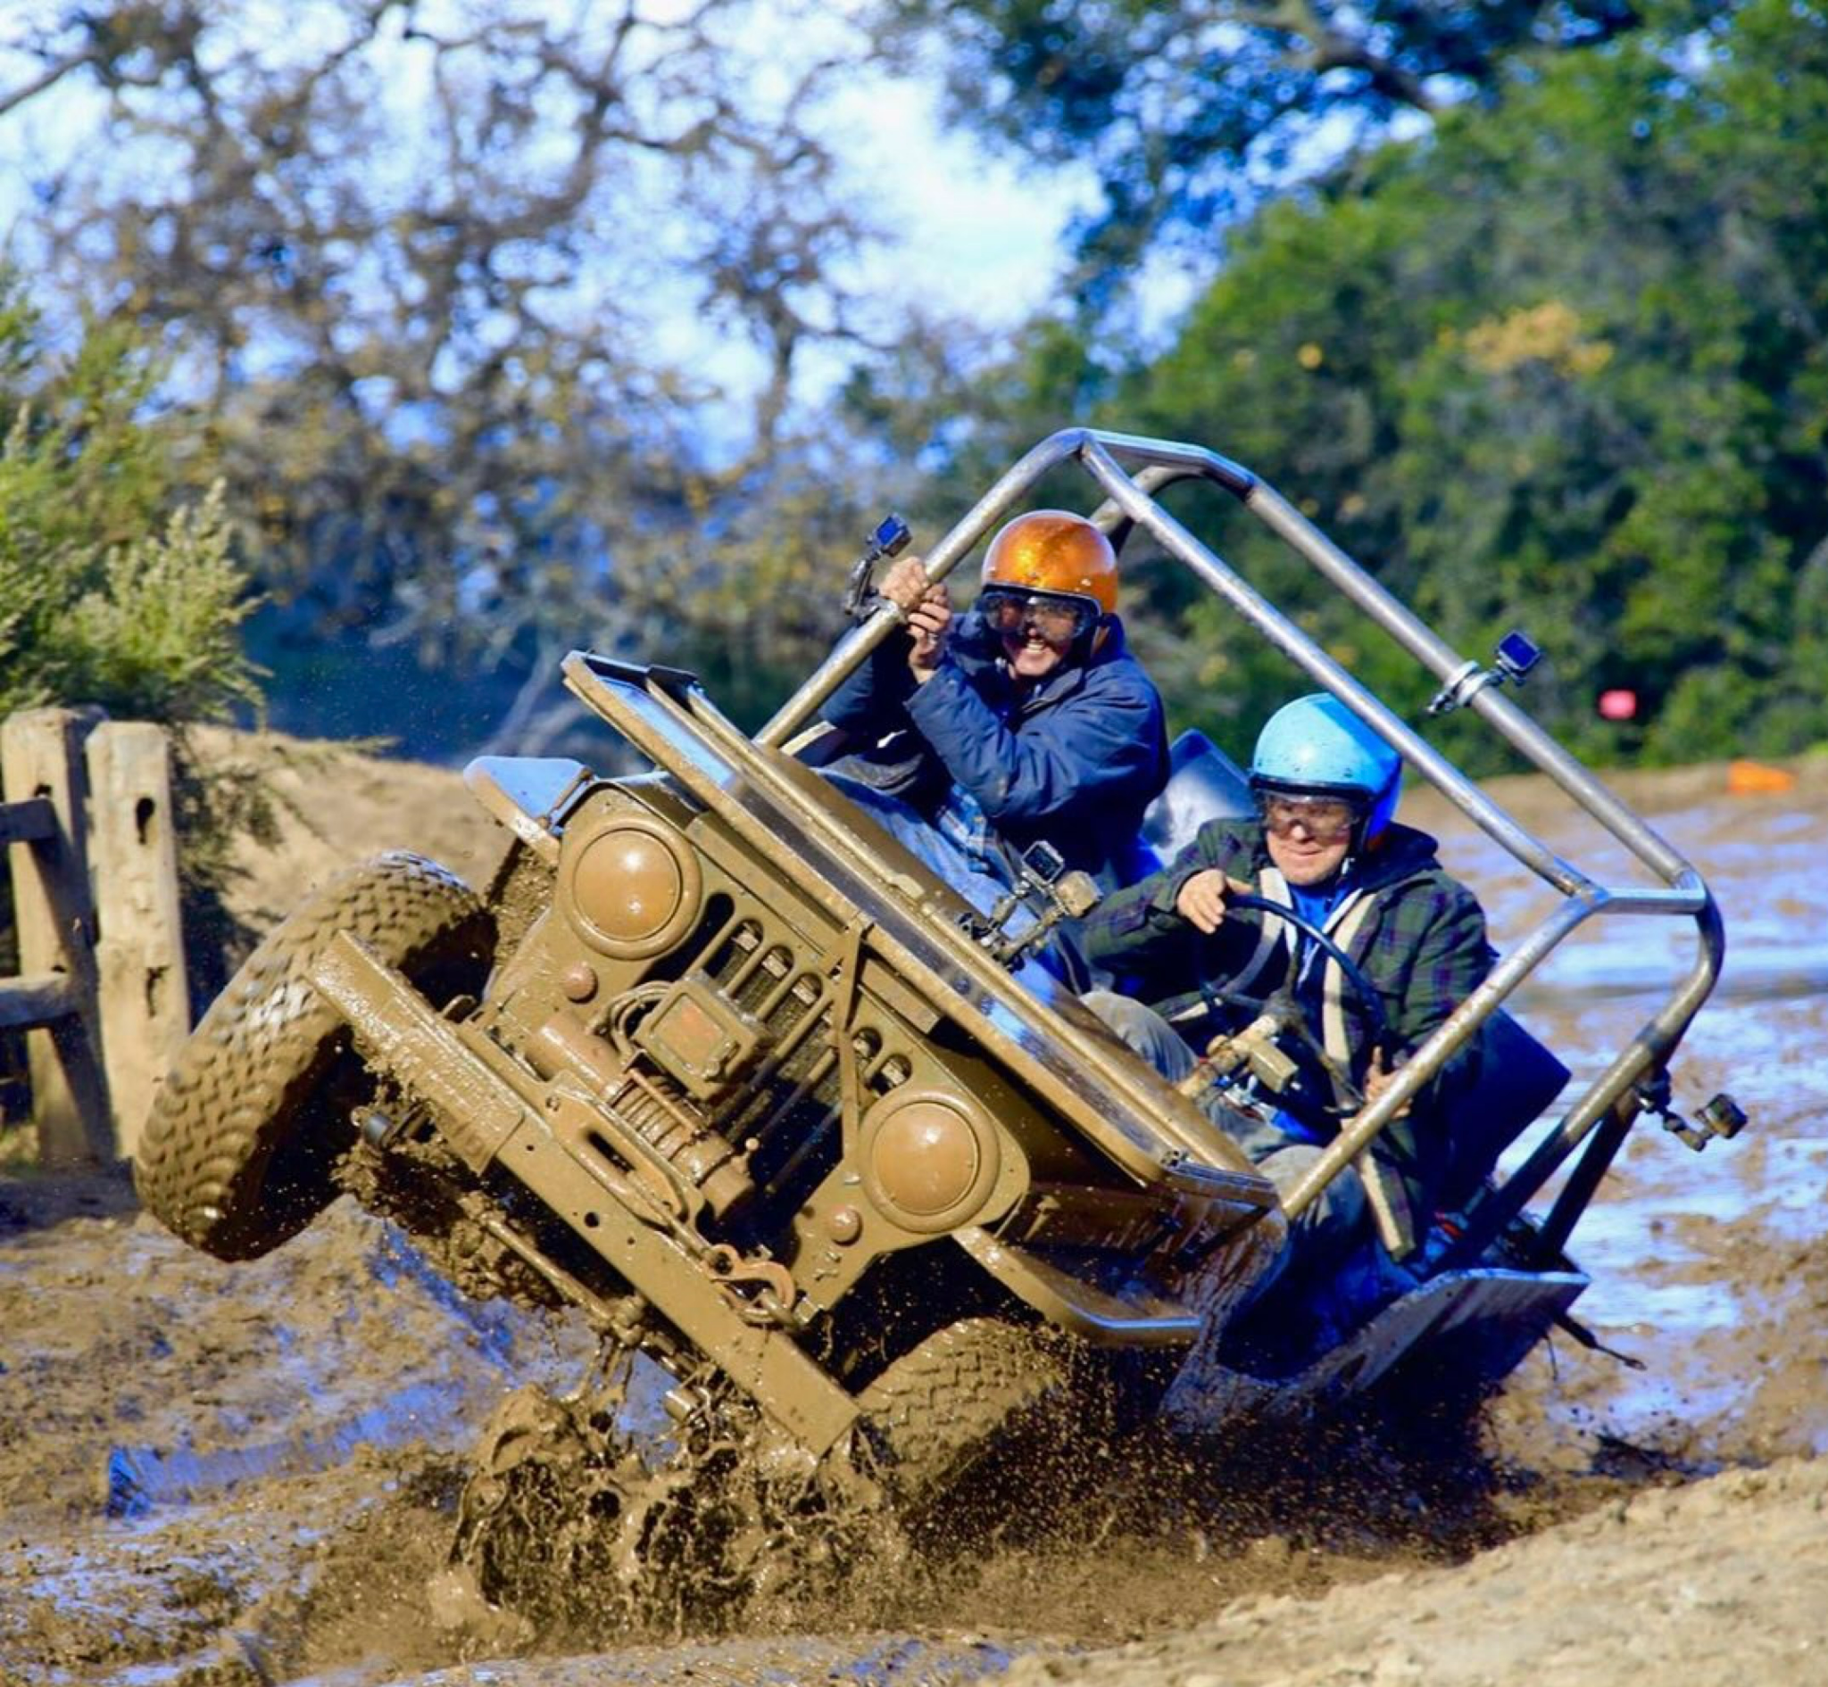
Fred Williams, Dave Chapelle from Dirt Every Day

Also, joining Bestop in the booth will be JOIIIO, a company that is revolutionizing the way you remove, store, and reinstall Jeep hard tops. This fast-growing outfit is partnering with Bestop’s Bestek home installation service for our line of soft tops and doors for Jeeps.

Bestop will be at SEMA 2022 in Las Vegas, NV from November 1-4, and we can be found at Booth #55101. For more information, contact 303-464-2549.

About Bestop
Owned by Kinderhook Industries and Magna, Bestop Inc. is the world’s largest manufacturer of premium soft tops and accessories for Jeep, Bronco, and trucks manufactured with North American-made craftsmanship. Through acquisition, the Bestop Premium Accessories Group consists of Bestop, Tuffy Security Products, Baja Designs, PRP, Softopper, SpeedStrap, BullRing, Aluminess, sPod, MGP Caliper Covers, and Status. For more information, visit www.bestop.com, call 800-845-3567 or email CSBestop@Bestop.com. You can also follow us on Instagram @bestopteam Facebook: @BestopTeam, Twitter: @Bestop_Team.

