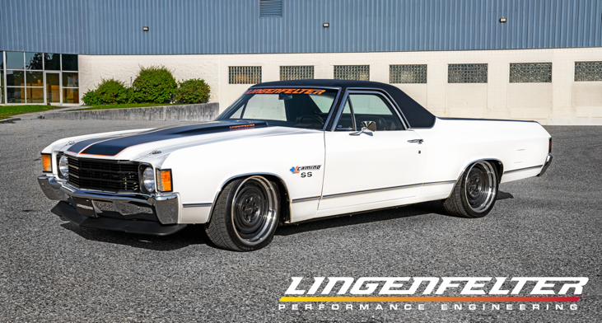
Lingenfelter Performance Engineering & Chevrolet Performance Collaborate to Electrify 1972 El Camino

Chevrolet Performance collaborated with Lingenfelter Performance Engineering to electrify a vintage 1972 El Camino SS for the very the first independent installation of the concept Electric Connect and Cruise eCrate Package at the Lingenfelter Build Center in Wixom, MI.

The installation was performed by a trained team at Lingenfelter, as part of Chevy Performance’s pilot program to validate the system for retro fit installations and establish a certification program for independent installers. Following the program’s expected launch in the first half of 2022, Chevrolet Performance’s Electric Connect and Cruise eCrate systems will be sold through GM Dealers and installed by qualified Electric Specialty Vehicle Modifiers (ESVMs); with Lingenfelter Performance Engineering being the first.

The bed of the “eLcamino” Concept Vehicle houses the 66-kWh battery pack, with the drive motor, supporting electronics and thermal management systems components mounted under the hood. A standard four-speed automatic transmission connects with the drive motor to send power to the rear axles, which allows it to shift through the gears like a conventional ICE powered system. Availability of instantaneous torque makes it fun to drive.

The learning from Lingenfelter Performance Engineering team’s successful installation of the concept Electric Connect and Cruise eCrate package will help develop the future of the program and the ESVM process.

This OEM and aftermarket collaboration opens exciting new opportunities for the aftermarket performance community and will draw a new demographic of enthusiasts, said Mark Rapson, COO/VP of Operations at Lingenfelter. The project not only validated the concept but demonstrated the excitement EV performance offers. The performance and fun factor of driving the car has impressed everyone who has had the opportunity behind the wheel, said Rapson.

The eLcamino made its debut in the EV Performance zone Chevrolet Performance Booth at the December 2021 PRI show in Indianapolis, Indiana.

