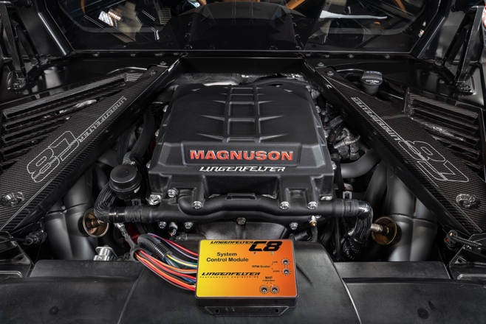

Lingenfelter Performance Engineering and Magnuson UNLEASH More Horsepower for the C8 Corvette!!!

OVER a Year of Development! HOURS of Dyno Testing! UNLEASHED, and It’s Real! Lingenfelter and Magnuson have created more horsepower for the C8 Corvette. It took over a year of innovative engineering, intense development, rigorous road testing, and proven validation, they did it! The package was developed to integrate seamlessly with the factory Corvette C8 systems while retaining like stock drivability.
Feeding Magnuson's patented DFT supercharger porting is the Lingenfelter Performance Engineering Ported LT5 95 mm Throttle Body which connects directly with the stock air intake system to retain proper airflow management. The key optimum performance is cool, dense air intake temperatures. Magnuson's charge air intercooler optimizes even air flow to maintain ideal IAT temperatures. To cool the water feeding the Magnuson 705 Horsepower TVS2650 C8 Corvette DI Supercharger Lingenfelter has engineered a unique heat exchanger system utilizing air passing under the car and through the side air intakes. This system includes a 1.5-gallon self-purging coolant reservoir tank.
For flawless integration Magnuson's patent pending supercharger drive system retains factory belt line, stock location of dry sump, oil components, bulkhead connections and electrical placement.
At the heart of this Lingenfelter by Magnuson 706 Horsepower TVS2650 C8 Corvette Magnum DI Intercooler Supercharger Package is the advanced programmable Lingenfelter Performance Engineering C8 Corvette System Control Module with flash capable circuitry. This module generates an algorithm managing map or boost pressure, mass airflow, ignition timing and throttle position in conjunction with the factory controls. This allows the factory ECM to properly manage air fuel ratios using signals from the factory wide bands stage.
Lingenfelter’s Stage 1 C8 Corvette Supercharger is complete, and production is currently underway. Based on current component supply chain timing our target release date is mid to late March 2022. We will be releasing final pricing, install details and warranty information in the first quarter of 2022.
Here’s what you will get out of the Lingenfelter by Magnuson 705 Horsepower TVS2650 C8 Corvette Magnum DI Intercooler Supercharger Package
- 705 Horsepower @ 6 psi boost
- 667 FT-LBS Torque @ 6 psi boost
- Lingenfelter by Magnuson TVS 2650 Magnum DI Intercooler Supercharger
- Lingenfelter Performance Engineering C8 Corvette System Control Module
- Lingenfelter Performance Engineering Ported LT5 95 mm Throttle Body
- Lingenfelter Performance Engineering Heat Exchanger
- Lingenfelter Performance Engineering 1.5 Gallon Reservoir Tank and intercooler pump
- Lingenfelter Magnuson C8 Corvette Supercharger System Requires Professional Installation
Additional Performance Data Available by the end of January 2022 Once Track Testing is Complete.

Additional Information
Lingenfelter by Magnuson 705 Horsepower TVS2650 C8 Corvette Magnum DI Intercooler Supercharger Package Product Page & Release Information Sign Up https://www.lingenfelter.com/lingenfelter-magnuson-705-horsepower-tvs2650-c8-corvette-di-supercharger

Product Videos

Lingenfelter Magnuson C8 Corvette Supercharger System https://youtu.be/vd1yN0q9sDo

Lingenfelter & Magnuson UNLEASH C8 Corvette HORSEPOWER https://youtu.be/kyUf2W5G6uc

Lingenfelter 705 HP C8 Corvette Teaser https://youtu.be/mIrmos9B4-w

