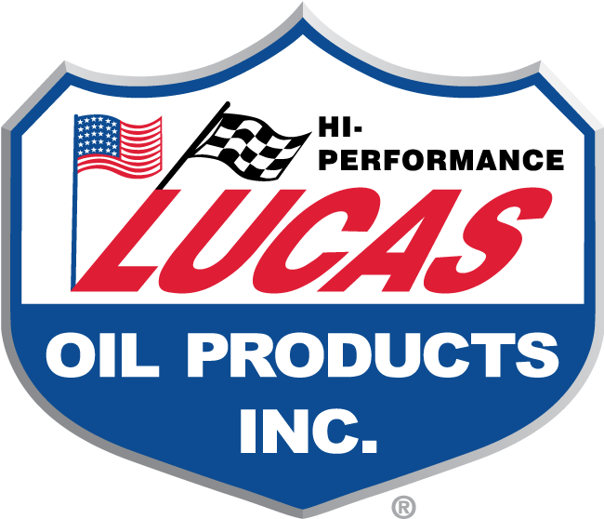
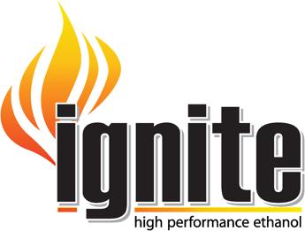
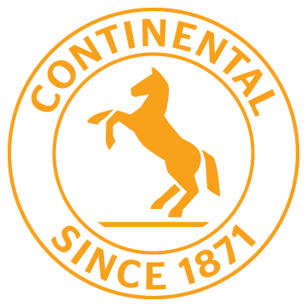

Lingenfelter’s Strategic Partnerships with Continental Tire, Lucas Oil & Ignite Racing Fuel

2022 is looking bright for Lingenfelter Performance Engineering with their strategic partnerships with Continental Tire, Lucas Oil and Ignite Racing Fuel.

Lingenfelter Performance Engineering has a long-term agreement with Continental Tires. As the official tire of Lingenfelter Performance Engineering, Continental’s line of performance tires will be featured on all Lingenfelter cars, trucks and SUVs on the street as well as at the track. They have also worked with Continental to test tires for performance at the track providing valuable feedback for development purposes.

Partnering up with premium line of oils, greases and problem-solving additives was obviously a logical step and that is where Lucas Oil steps in to complement Lingenfelter’s performance tuning expertise, which will help them get the most from our vehicles, on and off the track.

For Lingenfelter the need for quality high performance fuel was filled by Ignite Racing Fuel. As the official fuel of Lingenfelter their team drivers are taking home top wins at the track in major races across the country.

All of our partners are represented across the nation at Lingenfelter Performance Engineering sponsored events which can be found at www.lingenfelter.com/events.html

As Lingenfelter Performance Engineering gets further into 2022 they look forward to developing even more synergy with new strategic industry partners.

