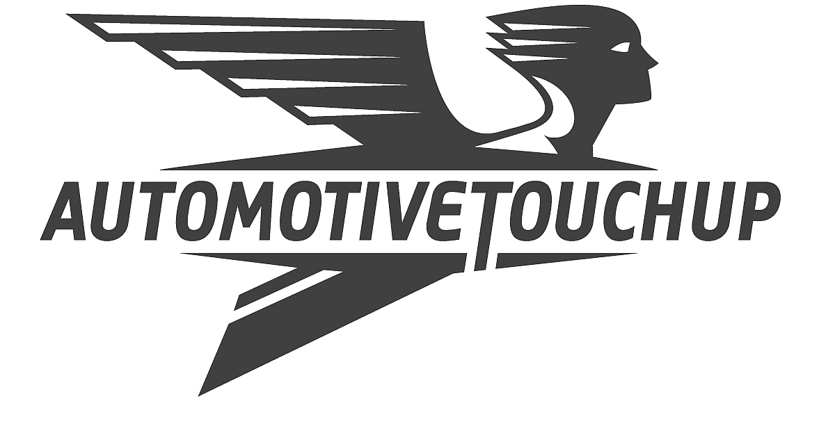

AUTOMOTIVETOUCHUP™ – CUSTOM COLOR EXPERTS
For over a decade AutomotiveTouchup™ has been creating the highest-quality specialty automotive paints from a state-of-the-art facility in New Orleans. The company manufactures precision-matched touchup paint products in aerosol cans, bottles, pens, and also in pints, quarts and gallons. AutomotiveTouchup is the flagship brand of Microfinish LLC, a leading supplier of coatings specially formulated for ease of application, durability, and diminished environmental impact. Products are direct shipped to customers to provide the highest quality products at the lowest cost possible.
Precision Color Expertise
AutomotiveTouchup products are custom-formulated from the most comprehensive library of OEM colors in the industry to create an exact color match. An easy to navigate online tool using the vehicle’s year, make, model and color code is designed to provide accurate color selection.
Innovative High-Quality Products
AutomotiveTouchup products offer the best value for excellent quality and custom color match. Each complete DIY system includes high-build, sandable primers, durable, fast-drying basecoats, and a proprietary formula clearcoat for a long-lasting glossy finish.
To help DIYers achieve professional-looking results, aerosol product cans feature an exclusive pro-grade spray tip which delivers a wide and finely-atomized spray fan that is as close to spray gun quality as possible. For larger projects, ready-to-spray pints quarts and gallons are available.
AutomotiveTouchup specially-designed DIY paint pens and bottled paints deliver precise application and a flawless finish, for convenient and cost-effective automotive touchup projects.
In addition, a complete line of body repair products is available to enhance ease of application and create professional-looking results.

Responsive Personal Support
Experienced and knowledgeable ATU staff members are available to answer customer questions, provide workable solutions or insights and ensure customer satisfaction. For more detailed instructions, AutomotiveTouchup.com offers informative and easy-to-understand videos for application instruction guidance.
About Microfinish LLC
Microfinish is a leading manufacturer of touch up coatings for vehicular and industrial equipment repair and refinishing. The company is dedicated to creating products that meet the highest standards for human and environmental health and safety, with volatile organic compound levels reduced to below national Department of Environmental Quality regulations and industry standards.
Contact
For more information on AutomotiveTouchup products and support, call 1.888.710.5192 or visit www.automotivetouchup.com.
# # #

