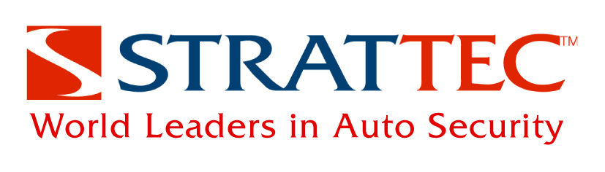

ABOUT STRATTEC
BOLT Locks are made by STRATTEC Security Corporation. STRATTEC Security, headquartered in Milwaukee, Wisconsin, is one of the world's largest producers of automotive locks and keys. STRATTEC designs, develops, manufactures and markets mechanical locks, electronically enhanced locks and keys, and ignition lock housings; access control products, including latches, power sliding door systems, power lift gate systems, power deck lid systems, door handles and related access control products for North American and global automotive customers. STRATTEC ships products to customer locations in the United States, Canada, Mexico, Europe, South America, Korea and China, and provides full service aftermarket support. STRATTEC also supplies products for the heavy truck and recreational vehicle markets, as well as precision die castings.

Formerly a division of Briggs & Stratton, STRATTEC's heritage goes back over 100 years to the early days of the automobile. Our long-term success is a result of our dedication to serving our customers and continuously improving our processes and product quality. Today, STRATTEC approaches business on a global basis, establishing strategic partnerships around the world.

STRATTEC's history in the automotive business spans 100 years. STRATTEC Security Corp. common stock is traded on the NASDAQ under symbol STRT. For more information, visit www.boltlock.com.
# # #

