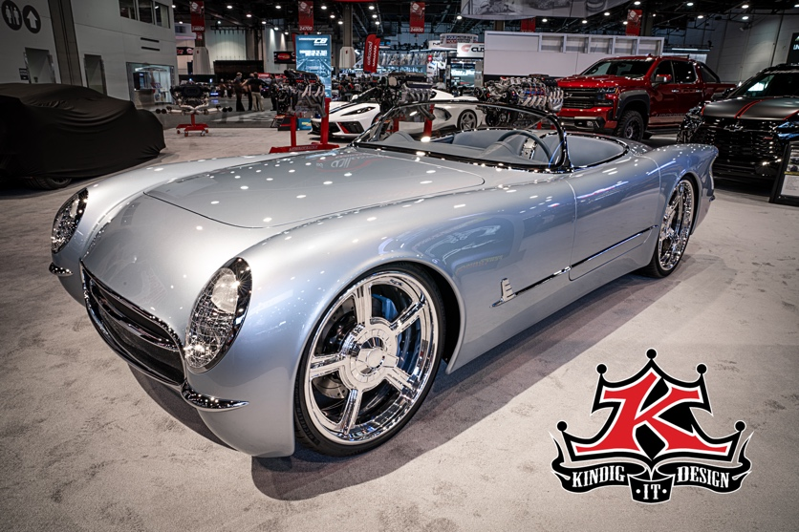

Lingenfelter Performance Engineering Build High Performance Motors for in Kindig-It-Design Custom CF1 Roadsters

Lingenfelter Performance Engineering is building custom high-performance motors for Dave Kindig the personality on the hit TV show Bitchin’ Rides the owner of Kindig-it Design in Salt Lake City, Utah for their new custom built Kindig-It-Design CF1 Roadsters.

The Kindig-It-Design CF1 Roadster is powered by a Lingenfelter Performance Engineering LS7 with LS3 which puts out about 673 horsepower and 684 pounds of torque. The car weighs in at a 3025 pounds with a full tank of gas so be sure if you have the privilege to drive one of these beauties, be sure you know what direction you're headed and keep the wheels straight.

Starting from the front to back, the headlights, bumpers, trim are all sand casted one off and unique to the CF1 Roadster. There are also a lot of body mods in this car and because typically it is very hard to fit us very tall person in this type of car Dave made adjustments while still keeping the stock wheelbase. By stretching the doors 2 ½”, stretching the cabin, dropping the seats and kicking the toe board forward a couple inches a 6’5” driver fits comfortably in this car without looking silly.

If you take a look at the 21-inch wheel fitting in the front, Kindig-It-Design wrapped the wheel wells around the wheels both front and rear and they chopped the windshield down from a stock height of about 3 ½” for a better look.

The Kindig-It-Design CF1 Roadsters are offered exclusively through Kindit-It-Design at $375,000 and the current build number available is #10.

Videos

Dave Kindig's CF1 Roadster at the Lingenfelter Booth | SEMA 2021 https://youtu.be/zxMaLssgdxc

Videos Tour of the Kindig-it CF1 Roadster #2 | SEMA 2021 https://youtu.be/Agu6Pn8SRo0

