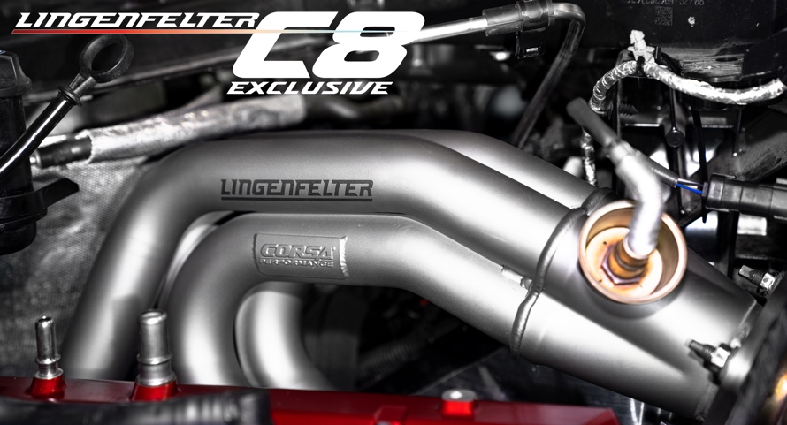

Lingenfelter & Corsa Team Up to Provide C8 Corvette Exhaust & Header Upgrades

Lingenfelter Performance Engineering have teamed up to take the performance of C8 Corvette owners to the next level. With many options to choose from there is no doubt you will find just what you are looking for when it comes to from mild to extreme.

When it comes to performance exhaust systems the showstopper seems to be the Lingenfelter Corsa Extreme-S C8 Corvette Exhaust for those who want to best in performance and sound. The Lingenfelter Extreme-S C8 Exhaust was jointly engineered with Corsa Performance out of stainless steel to be the BEST 4 valve C8 exhaust system on the market. The Extreme-S exhaust offers REAL engineered performance gains and AGRESSIVE sound while retaining the OEM 4 valve design for drone free driving on the freeway and factory exhaust controls. This system has been proven and tested on the racetrack and engineered to CORRECTLY integrate with the factory ECM. The exhaust provides a performance increase of +19 RWHP and +15 RWTQ and a weight savings of 13 lbs. over the OEM system.

The CORSA C8 Corvette Variable Sound Level 3.0 in CAT-Back Quad NPP Exhaust puts control at the driver’s fingertips allowing them to maintain full control of the C8 Corvette sound profile with fully functional CORSA Cast NPP valves that integrate seamlessly to the stock C8 actuators. Each NPP system is both Louder (+9 decibels) and quieter (-1 decibel) than that stock system and incorporates CORSA’s proprietary RSC® Technology providing a drone free driving experience while still allow the 6.2L LT2 engine to release aggressive exhaust notes under heavy acceleration. This system replaces the AFM valve with a machined simulator bracket engineered specifically to prevent an AFM Check Engine Light. Perfect for aggressive drivers who plan on driving primarily in “Track” Mode.

Like the CORSA performance Track Series the CORSA C8 Corvette XTREME Sound Level 3.0 in AFM CAT-Back Quad Exhaust is made for drivers seeking an ultra-aggressive exhaust note without resonance caused by 4-cylinder economy mode operation. CORSA’s AFM Only C8 cat back exhaust systems are designed to eliminate restrictions, maximize weight savings, and bring the noise while eliminating resonance from 4-cylinder mode. Each system has been Track-Tested and Dyno proven to maximize performance producing up to 18 HP and 16 LBS Ft. of TQ. All while shaving 25 pounds from the stock exhaust system.

CORSA C8 Corvette XTREME Sound Level 3.0 IN CAT-Back Quad Exhaust with 4.5 in Tips offers pure sound with no restrictions, made for the track, not your neighbors. CORSA C8 Corvette XTREME Sound Level 3.0 IN CAT-Back Quad Exhaust systems are designed exclusively to eliminate restrictions, maximize weight savings, and bring the noise. Each system has been Track-Tested and Dyno proven to maximize performance producing up to 18 HP and 16 LBS Ft. of TQ. All while shaving 27 pounds from the stock exhaust system.

The Lingenfelter CORSA 1 7/8" Pipe to 3.0" Collector C8 LT2 Corvette Headers maximize performance and sound gains without the need for tuning, so once installed, you are ready to hit the street or track. The 1 7/8" primaries are made of quality 304 stainless steel to maximize flow and emphasize the sound. They bolt directly in front of the stock catalytic converter and are emissions legal.

The C8 Corvette as designed is a work of art, featuring stunning body lines and supercar levels of performance. Yet there are still areas where the aesthetics can be improved. Heat shielding has been utilized as necessary throughout the C8 engine cavity and exhaust system to protect the vehicle from excessive heat generated from the V8 engine. Behind the rear wheels, GM used reflective heat material to reduce heat soak, which creates and eyesore against the otherwise gorgeous lines of the C8 rear valence. The CORSA C8 Corvette Black Out Heat Protection replaces GM’s reflective heat wrap with an added layer of black heat protection eliminating the eyesore behind the C8 Exhaust Tip cavity.

More Information

Product Links

- Lingenfelter CORSA Extreme-S C8 Corvette Exhaust https://www.lingenfelter.com/corsa-extreme-s-c8-corvette-exhaust
- CORSA C8 Corvette Variable Sound Level 3.0 in CAT-Back Quad NPP Exhaust with 4.5” Tips https://www.lingenfelter.com/corsa-c8-variable-sound-level-3-inch-cat-back-quad-npp-exhaust
- CORSA C8 Corvette XTREME Sound Level 3.0 in AFM CAT-Back Quad Exhaust with 4.5” Tips https://www.lingenfelter.com/corsa-c8-corvette-xtream-sound-level-3-inch-afm-cat-back-quad-exhaust
- CORSA C8 Corvette XTREME Sound Level 3.0 IN CAT-Back Quad Exhaust with 4.5 in Tips https://www.lingenfelter.com/corsa-c8-corvette-xtreme-sound-level-3-inch-cat-back-quad-exhaust
- Lingenfelter CORSA 1 7/8" Pipe to 3.0" Collector C8 LT2 Corvette Headers Product Link https://www.lingenfelter.com/corsa-c8-lt2-corvette-headers
- CORSA C8 Corvette Black Out Heat Protection https://www.lingenfelter.com/corsa-c8-corvette-black-out-heat-protection

Videos

Lingenfelter Corsa Extreme-S C8 Corvette Exhaust | Stock Exhaust Comparison
https://youtu.be/xHjR_aQ7Av4

Lingenfelter Extreme-S C8 Exhaust https://youtu.be/Nl9dL_L7S-4

Lingenfelter Extreme-S C8 Exhaust - Launch Video https://youtu.be/3Hevb7LFQT8

