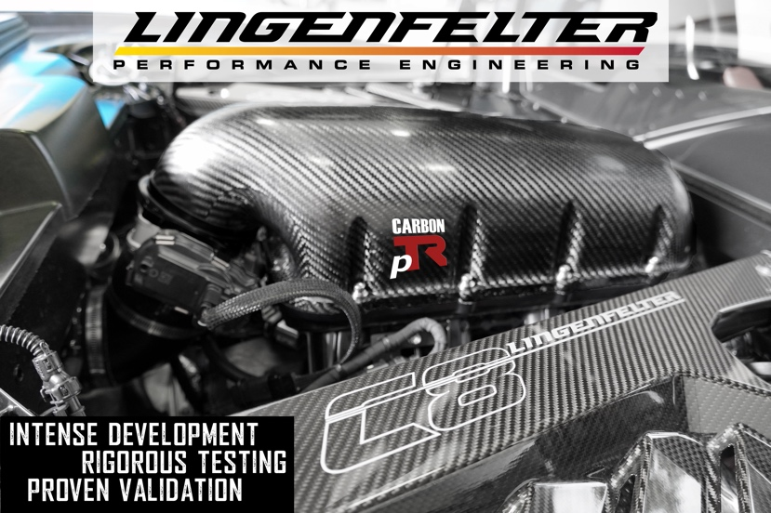
PRESS RELEASE

Lingenfelter Launches Performance Design Carbon pTR Intake Manifold System for C8 LT2 Corvettes

After a year of intense development, rigorous testing, and proven validation, the SEMA 2021 Global Media Award Winning Performance Design Carbon pTR Intake Manifold is ready for the street as well as the track and available exclusively through Lingenfelter Performance Engineering.

Producing an additional 25 horsepower at the rear wheels on average when used with the Lingenfelter 95 mm Throttle Body, the Performance Design Carbon pTR Intake Manifold takes stock C8 LT2 Corvettes to the next level with style and performance. It features a great-looking 5-layer carbon fiber upper and a durable heat-resistant glass-reinforced nylon lower while embracing lightweight tunnel ram architecture.

Innovative engineering allows for complete ECM integration using the factory connectors, and there is no calibration required.

The Performance Design Carbon pTR Intake Manifold is an all-inclusive, technically advanced system with absolutely everything, from the pressure tested Performance Design Carbon pTR Intake Manifold to the high-performance Lingenfelter 95 mm Throttle Body (if required). In addition, this advanced system includes the appropriate couplers, hoses, harnesses, gaskets, fasteners, and connectors which were specifically designed to work with the factory-installed connections and fittings on all C8 LT2 Corvettes. (Does not fit convertibles)

For more information or to schedule an install, give us a call at one of our Lingenfelter Performance Engineering Build Centers or send an email to sales@lingenfelter.com or call (260) 724-2552.

1557 Winchester Rd, Decatur, IN 46733 | 47451 Avante Dr, Wixom, MI 48393

Additional Information
Performance Design Carbon pTR C8 Corvette Intake Manifold
Product Page https://www.lingenfelter.com/performance-design-ptr-carbon-fiber-c8-lt2-corvette-intake-manifold

Videos
Performance Design Carbon pTR C8 Corvette Intake Manifold
https://youtu.be/_rF1rc1fnuI

Tour of Driver Andy Voelkel's Lingenfelter C8 https://youtu.be/w6CNacBRW-A

