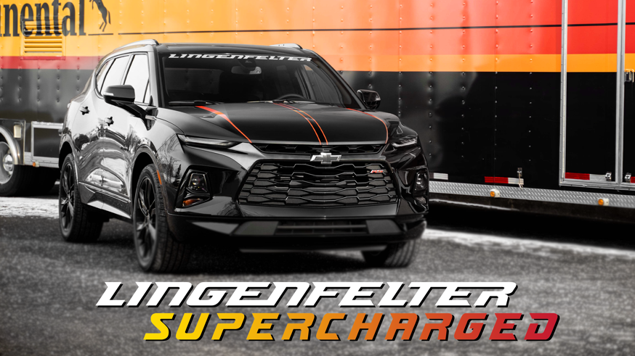

Lingenfelter to Launch Magnuson Supercharger for the NEW Chevy Blazer in 2022

Wanting more horsepower for your new Chevy Blazer? The wait is almost over as Lingenfelter Performance Engineering is working closely with Magnuson to make that dream a reality in 2022.

CHECK BACK FOR MORE INFO AND UPDATES TO THIS PRESS RELEASE.

