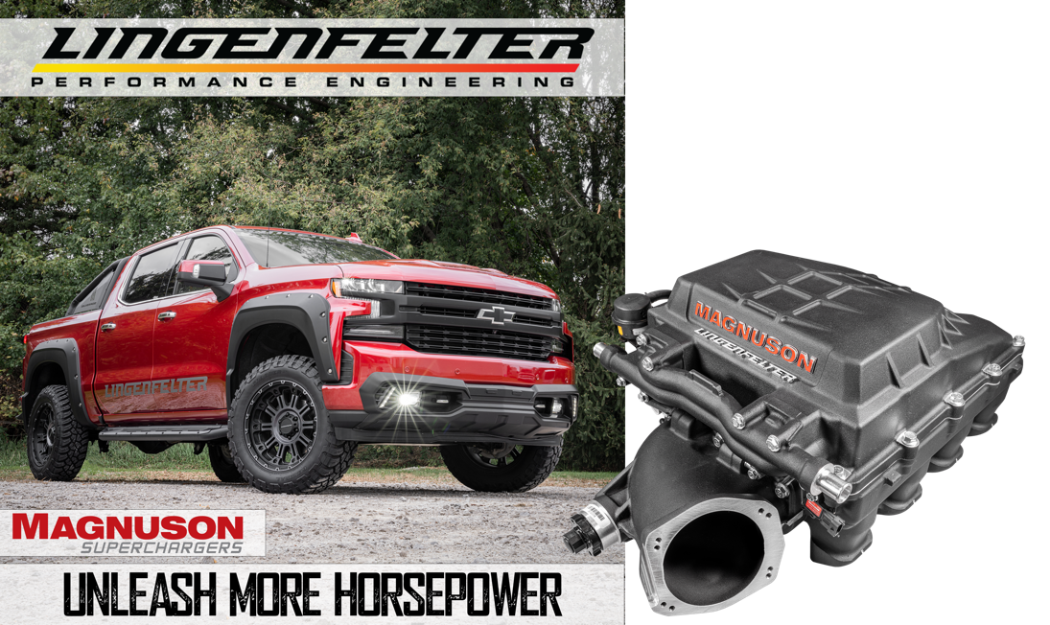
Lingenfelter Launches Exclusive Magnuson C8 Intercooled Supercharger Package for 2019⁺ 5.3L & 6.2L GM Trucks

Lingenfelter and Magnuson combine their innovative engineering expertise to unleash +45% more horsepower for 2019 and later DI 5.3L and 6.2L General Motors Chevy Silverado & GMC Sierra Trucks.

Magnuson’s TVS 2650 GM DI Truck Intercooled Supercharger (CARB-pending) is paired with Lingenfelter Performance Engineering’s integrated control system giving trucks an additional 150+ RWHP and 100 RWTQ offering incredible acceleration, improved towing performance, and enhanced off-road ability while retaining excellent drivability and little change to fuel economy.

The supercharger utilizes advanced Eaton TVS (r) high helix four-lobe rotor technology for maximum efficiency across the entire RPM range. In addition, a unique lid and intercooler geometry was developed to optimize airflow evenly across the high-efficiency charge air intercooler for maximum cooling.

The Lingenfelter exclusive Magnuson TVS 2650 Supercharger is an all-inclusive, technically advanced package designed to fit L86 heads. The inlet features patented DFT porting and is compatible with a stock L86 90mm throttle body, LT5 95mm Lingenfelter Performance Engineering Ported LT5 95 mm Throttle Body, and up to a Nick Williams103mm.

For more information or to schedule an install at a Lingenfelter Performance Engineering Build Centers, give us a call at (260) 724-2552, send an email to sales@lingenfelter.com.

Lingenfelter Performance Engineering Build Centers
47451 Avante Dr, Wixom, MI 48393 | 1557 Winchester Rd, Decatur, IN 46733
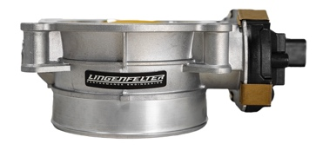
3-Year/36,000 Mile Warranty
5.3L engines will require an L86 6.2-liter throttle body or a 95mm such as the Lingenfelter Performance Engineering Ported LT5 95 mm Throttle Body.

Additional Information

Lingenfelter Exclusive Magnuson GM Magnum DI 5.3 & 6.2L Intercooled Supercharger Package Product Page

https://www.lingenfelter.com/magnuson-gm-di-5.3-6.2l-truck-intercooled-supercharger-package-2019-newer

Videos

Lingenfelter Exclusive Magnuson GM Magnum DI 5.3 & 6.2L Intercooled Supercharger Package - GM Trucks
https://www.youtube.com/watch?v=TII9qv3UEKU

Lingenfelter Exclusive Magnuson GM Truck Supercharger System | Wixom, MI Build Center Installation
https://youtu.be/8bmqvy82yGQ

