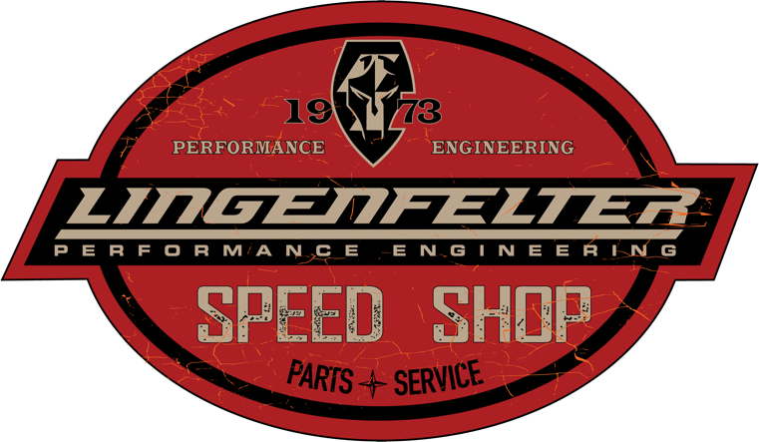

Lingenfelter to Launch Speed Shop in Wixom, MI in Spring of 2022

Lingenfelter Performance Engineering is thrilled to announce the launch of their Lingenfelter Speed shop at their Wixom, Michigan build center located at 47451 Avante Drive this spring. You will find a showroom full of goodies for the avid car enthusiast.

CHECK BACK FOR MORE INFO AND UPDATES TO THIS PRESS RELEASE.

