PRESS RELEASE

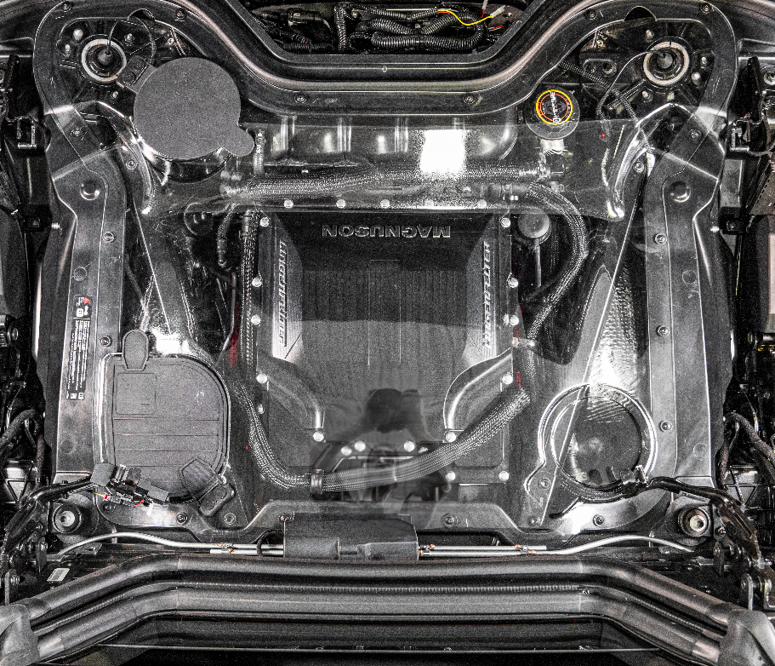
September 14, 2022
Detroit Auto Show

Lingenfelter Performance Engineering and Magnuson Release MORE Horsepower for the C8 Corvette Convertible!!!

Lingenfelter Performance Engineering, known for its Corvette engineering excellence, shows off a new supercharger package for the Corvette C8 Convertible at the 2022 Detroit Auto Show. The system uses the same TVS 2650 system developed for the C8 Coupe and first shown at the 2021 SEMA show. The Coupe and Convertible produce an incredible 700 HP and 675 TQ without compromising the factory systems, drivability, and has very little impact to the fuel economy.

Like the Coupe, the fully integrated system features a Lingenfelter by Magnuson TVS 2650 DI Intercooled Supercharger and Lingenfelter Performance Engineering Ported LT5 95 mm Throttle Body. It also includes the proprietary Lingenfelter XCT Heat Exchanger System for maintaining low intake air temperatures to produce maximum power and reliability. The package was developed and tested jointly with Magnuson Superchargers.

The coupe system will be released on October 1st, 2022, with the HTC program to be released on January 1st, 2023. Pricing, warranty, performance numbers, and other details for both systems will be announced on October 1st, 2022.
Lingenfelter by Magnuson 700 Horsepower TVS2650 C8 Corvette Magnum DI Intercooler Supercharger Package Product Page https://www.lingenfelter.com/lingenfelter-magnuson-700-horsepower-tvs2650-c8-corvette-di-supercharger-package
Photos https://www.dropbox.com/sh/0wuzfsa5h32w9qr/AACAh94aQbeYbe2dEnN4X1PGa?dl=0

