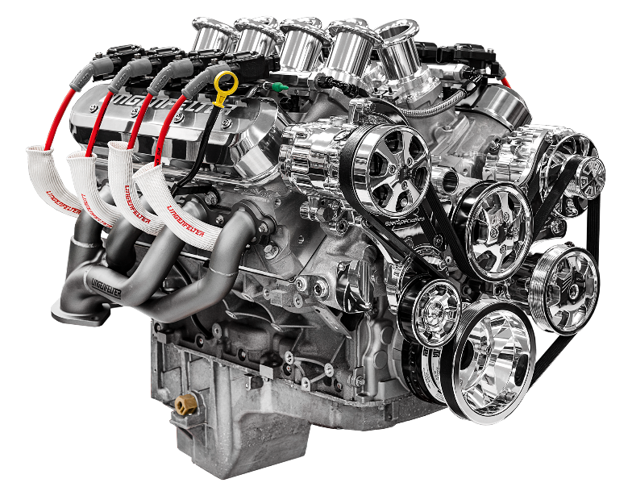
Make-A-Wish for MORE HORSEPOWER Lingenfelter Eliminator Spec Engine Raffle Benefiting Make-A-Wish Foundation
Lingenfelter Build Center Wixom, MI April 14, 2022
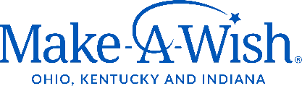
Lingenfelter is more than turning innovative engineering into winning performance; they like to get involved, and this time, they are helping children with critical illnesses make their life-changing wishes come true through the Make-A-Wish foundation.
Priceless wishes are granted for children, plus the winner takes home a $30,000 Lingenfelter Performance Engineering Eliminator Spec Engine Built to the 1953 Kindig-It CF1 Roadster specifications.
Lingenfelter Performance Engineering Eliminator Spec Engine
- 650 Horsepower
- Lingenfelter 427 LS Engine
- Lingenfelter LS3 Ported Heads with LSX Springs
- Borla 8-Stack Injection
- Billet Specialties Tru Trac Front Drive
- Forged & Balanced Rotating Assembly
- Lingenfelter Roller Camshaft
- Lingenfelter Certificate of Authenticity
- Signed by Dave Kindig and Ken Lingenfelter
The Lingenfelter Performance Engineering’s Eliminator Spec Engine Program of custom-built engines are “ENGINEERED FOR THE TRACK, BRED FOR THE STREET.” All Lingenfelter Eliminator Spec S, R, and X Engines represent the ultimate in street or track performance and are designed to the highest standard of durability and reliability.
To add to the excitement, the winning raffle ticket will be randomly drawn by Dave Kindig, owner of Kindig-It-Design and the star of the hit TV show “Bitchin' Rides” at the Lingenfelter 21st Annual Blue Suede Cruise on July 30th, 2022.
The winner does not need to be present to win, but all are welcome to join the fun and meet our celebrity guests, Dave Kindig and Kevin Schiele “KevDogg,” for three days of 1978 and older hot rods, customs, classics, muscle cars & trick trucks. It is a great event for the entire family with a car show; fun runs, drag racing, manufacturers midway, great food, live music, fireworks, and a coloring contest for all ages judged by Dave Kindig and Kevin Schiele! It all happens July 29th-31st at the Summit Motorsports Park in Norwalk, Ohio.
Make-A-Wish Raffle Tickets https://donate.onecause.com/engineraffle
Event Info https://www.lingenfelter.com/lingenfelter-blue-suede-cruise.html
Event Tickets http://www.summitmotorsportspark.com/events/11290
Video Link https://youtu.be/GWPnybpyQTs Launching 4/15/2022

Dropbox Press Kit Assets Link https://www.dropbox.com/sh/snw0rn92lzoiyco/AADrbTE0BdmgMk9XTwhDVo7Ga?dl=0

