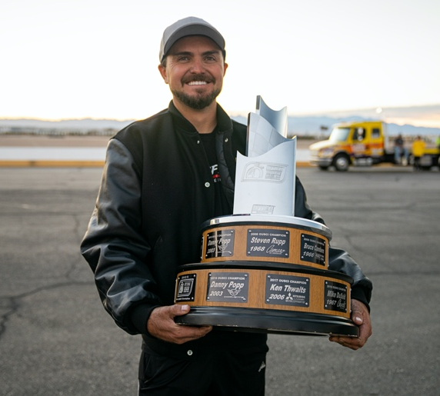

TEAM Lingenfelter Drivers

Jake Rozelle – 2003 C5 Z06 Corvette
Lingenfelter Eliminator R Spec 800+ Horsepower Motor

“ENGINEERED FOR THE TRACK, BRED FOR THE STREET”

Lingenfelter Performance Engineering support the Team Lingenfelter drivers that take the passion for motorsports to the limit as they set their eye on the prize. Every driver on the team is drives a GM car that has been taken to the next level with Lingenfelter Eliminator Spec Motors and performance parts.

Since 1973 Lingenfelter Performance Engineering has worked hard to offer winning performance through innovative engineering. Through rigorous testing and proven validation Team Lingenfelter has become a family of drivers from across the nation who bring the passion for motorsports in variety of categories.

Team Lingenfelter driver Jake Rozelle from Lake Havasu, Arizona took home the OPTIMA Ultimate Street Car 2021 Title after competing in eight seasons of OPTIMA's Search for the Ultimate Street Car. Rozelle won the title in 2021 behind the wheel of his 2003 C5 Z06 Corvette powered by an 800+ horsepower Lingenfelter Eliminator R Spec 454 LS7 Motor. The 27-year-old driver was tailing last year's defending champion, C.B. Ramey, at the halfway point but at the end, he won by a single point, taking vengeance from his one-point loss in 2020.

Dirk Stratton of Beloit, Ohio is a fan favorite to watch in his 2009 C6 Corvette powered by a Lingenfelter Eliminator R Series 427 V8 Motor with a Concept Performance LSR Block, ported LSX heads, forged internals, Diamond pistons, a custom ground camshaft with a Magnuson Heartbeat 2300 Supercharger which produces about 855 horsepower. "Drifting is controlled chaos and that's why I love it. Driving at 100% and pushing the limits of the car is so addicting" say’s Stratton.

Tracy Gaudu from Johnson City, TN and is truly a one-woman race team in her 2008 C6 Z06 Atomic Orange Corvette powered by a Lingenfelter built 650 Horsepower Motor. Gaudu races in the NASA Southeast Region in the Super Unlimited class as well as the TTU (time trial unlimited) class. She took home rookie of the year at Carolina Motorsports Park in November of 2021 and that same weekend won the double podium with a P1 in TTU. Tracy is also a three-time NASA SE Time Trial Champion (TT1 2019 & 2020, TTU 2021). Team Tracy Motorsport will be focusing more on wheel-to-wheel competition in 2022 and looking for that first championship!

Mike Rovere of Rapid City, South Dakota drove his Lingenfelter Eliminator R Spec LS7 Corvette into third place in the highly competitive GTL class and with a fourth-place overall win at the 2021 OPTIMA Ultimate Street Car Invitational securing more wins for Team Lingenfelter.

Father and son Brett and Andy Voelkel from Jasper, Indiana are also a part of Team Lingenfelter in their black and white C8 Corvettes with Lingenfelter Performance Design ptR Carbon Manifold Systems, Lingenfelter CORSA Performance Exhausts, Lingenfelter C8 Lowering Kits and Continental Extreme Contact Tires on Forgeline Wheels with Alcon Specialist Brakes. At the age of 13 Andy attended his first OPTIMA Ultimate Street Car Challenge watching his dad race. It was at that event that Andy got hooked and now at 22 years old he is out on the track and qualified for the 2021 OPTIMA Ultimate Street Car Invitational in his black C8 Corvette alongside his dad Brett in his white C8 Corvette. The passion for motorsports makes watching this father and son team truly something special.

Nathan Popp and his dad Danny Popp from West Chester Township, Ohio are also Team Lingenfelter father and son drivers. Nathan is another young Team Lingenfelter driver who earned an invite to the OPTIMA Ultimate Street Car Invitational with the power in his 1995 Z28 Camaro sporting an Eliminator Spec LS7 Motor. Following in his dad’s footsteps, Nathan took home the first place WIN in the GE Class for Team Lingenfelter after Danny Popp pulled off his three wins at the OUSCI in a row in 2016.

With an invite from Lingenfelter, Logan Palmer of Roseville, California and his Lingenfelter built LT5 powered C7 Corvette turned out some fast laps at the Las Vegas Motor Speedway for the OUSCI 2021 event at Las Vegas Motor Speedway as well.

Ashton Robinson from Menifee, California is one of the newest drivers on Team Lingenfelter in SCAR1LET, her 2015 1LE Camaro Eliminator S Spec 427 LS3 Motor. Robinson was out at the 2021 OUSCI giving it her all. Be sure to keep an eye out for Ashton as she tears up the track at future OPTIMA Ultimate Street Car Challenge events.

Bad Wolf Racing driver Lori Collett of Jacksonville, Florida will be joining Team Lingenfelter for the 2022 OPTIMA Ultimate Street Car Challenge season in her soon to be Lingenfelter powered 2018 Camaro.

Although not all the Team Lingenfelter drivers were mentioned, Lingenfelter is proud of each driver who trusts the engineering behind their power from performance parts to full engine builds.

#TeamLingenfelter will have more drivers joining the family in 2022 so be ready to see more Lingenfelter powered cars at the track this season!

Videos

Team Lingenfelter https://youtu.be/6M0_c0IwAhA https://youtu.be/42scmj2IKrU

Dirk https://youtu.be/8zYHbEj2YHM https://youtu.be/Qxw9czRd3rA https://youtu.be/k_yr6vuf99g

Tracy https://youtu.be/UVGwNNC7KpM

Brett and Andy https://youtu.be/J0dgjEu08BA

Andy https://youtu.be/w6CNacBRW-A https://youtu.be/S7Dovav8G7Y

Nathan https://youtu.be/-4PX8mQ14Xs

Mike https://youtu.be/JA6GETduk9E

Ashton https://www.youtube.com/watch?v=r6agcxBdl14

Holley LS Fest East Team Lingenfelter Drivers https://youtu.be/PBXmXBQukzQ

